**Important Basics for Blender**

Object Mode: Used to create new objects (on side tab where it says “create”) and to move your objects around the space.

Edit Mode: Used to edit the shape of the object you have highlighted.

Important Object Mode Hot Keys:

-Right click = select object

-In “Tools” tab, “Smooth” will make your object not look like a mess of polygons anymore

-In “Tools” tab, “Flat” will make your object have its polygons for its shape all visible

-X key = Delete (will give a prompt first before it works though, don’t worry)

-R key = Rotate

-Pressing the X, Y, or Z keys while in rotation mode will lock rotation to that axis  
 -V key = Switch to paint mode

-Ctrl + C = Copy object

-Ctrl + V = Paste object

-S = Scale up/down

-I (The letter “i”) key = Insert Keyframe (used for animations, I’ll explain that another time)

-T key = Hide/Unhide Toolbar

-G key = free move (you can also free move along a specific axis by dragging the object)

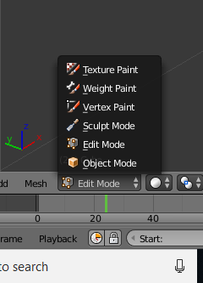Important Edit Mode Hot Keys:

<- Screencap on how to swap between modes

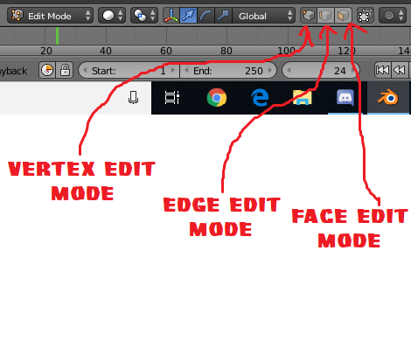

^ The above image tells you how to switch between editing different parts of an object in edit mode

-Right Click = Select vertex/edge/face you are hitting

-Shift + Right Click = Select multiple verticies/edges/faces

-Free moving verticies/edges/faces = drag around mouse

-Move verticies/edges/faces along a specific axis = Press X, Y, or Z when you have selections

-E key = Extrude (Create new edge/face based on your selections without affecting the rest of object)

-S key = Scale vertex/edge/face

-R key = Rotate vertex/edge/face

-T key = Hide toolbar

-W key = “Specials” menu for verticies/edges/faces

-F key = Create a face that spans along all of the verticies/edges/faces you currently have selected

-Z key = See-through mode/exit see-through mode

-C key = Circle selector mode (will select anything clicked that’s within the circle)

-N key = Open transformation menu

-B key = Drag selector mode (will select anything clicked within the area you drag the box)

Other Important Things to Note:

-You can connect objects to each other through usage of edges/vertices and then adding faces

-DO NOT select multiple objects at the same time prior to going into edit mode, as it will count them as the same object and screw everything up

-Going to “Render” and then “Render Image” at the top left of your screen will show the image from a specific angle, based on the position of your camera. Every Blender scene automatically comes with a camera that can be moved around itself.

-Check image below for usage of editing the camera and positioning of the camera:

